PLEIADES PAPER PRESENTATION

Theme : Wireless Communication,Computer Networks.

A GREENER APPROACH TOWARDS ENERGY EFFICIENT NETWORKING.

Stream Code - CPT-Computers

Team Members

- Name: Pavan Nadkarni
Email Id: pavank1104@gmail.com
Contact No: 9740643713
Branch: Computer Science Engg.
College: BVBCET

- Name: Prashanth Artal
Email Id: prashanth.artal@gmail.com
Contact No:9036672574
Branch: Computer Science Engg.
College: BVBCET

- Name: Sandesh Hardikar
Email Id: sandeshhrdkr52@gmail.com
Contact No: 9738813750
Branch: Computer Science Engg.
College: BVBCET
A GREENER APPROACH TOWARDS ENERGY EFFICIENT NETWORKING 1

A Greener Approach Towards
Energy Efficient Networking

1 INTRODUCTION
H E Internet has become an integral component of the economy of all developed and developing nations. All telecommunication networks require resources to function, particularly (electrical) power, to operate. The larger the network grows, the more electrical power it consumes. The rate of growth of the Internet, in terms of uptake and capacity increase, means that actually reducing its total power consumption is unlikely to be a realistic goal. A more practical goal is to improve the ”energy efficiency” of the Internet. By energy efficiency we mean the amount of data that could be conveyed from end to end per quantum of energy consumed
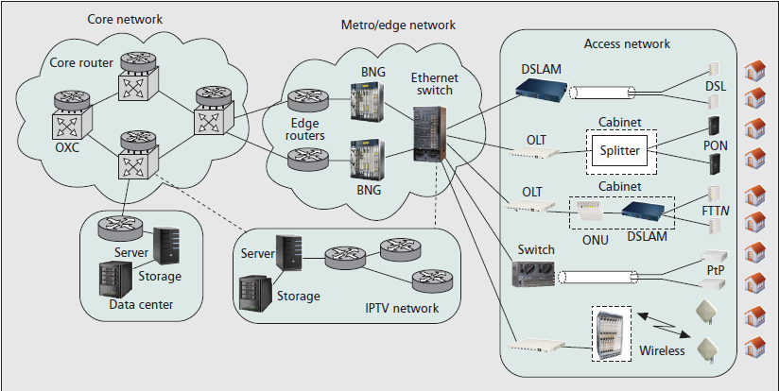

T
by the network.
This report presents the work done by leading researchers in the field of network energy efficiency in a laconic manner.It is organized as follows. In section 2, we identify components of the network that consume the most energy. The two energy hotspots identified are content distribution networks and access networks. Section 3 reviews content distribution and Section 4 concentrates on access networks. Attention is given to the network core in section 5, wherein efforts are put into making core routers sleep. Wireless Mesh Infrastructure (WMI) is considered in section 6 and cellular networks with a focus on ”embodied energy” in section 7. Section 8 takes up a radical approach to green networks via Cognitive Dimension.

2 POWER CONSUMPTION IN THE INTERNET
Internet is a complex engineering structure, and hence, any attempt to improve the overall energy efficiency is best focused on those parts that consume the most power. Therefore, a key step in this process is identifying those parts.
A model for estimating the power consumption in the Internet is based on the telecommunication network design principles as shown in Fig 1.
The major components of the network are access, metro, and core networks plus data centres and content distribution net- works. The access networks connect individual homes and businesses to their local exchanges. The local exchanges (or central offices) in a city are connected to each other and to other

Fig. 1: Model Showing various parts of Internet

cities via the metro/edge network. The core network comprises a small number of large routers in major population centres. These core routers perform all the necessary routing and also serve as the gateway to neighbouring core nodes.

2.1 Where the Power Goes
Some of the key contributors to power consumption in the Internet are Network Equipments, Capacity Planning, Services/Cloud Facilities, Demographics and Service scenarios. Using these analytical methods, a picture of the power consumption in the Internet is developed to gauge which parts of Internet consume the most power[1,8-11].

Fig 2 is a plot of the key contributors to power consumption (per customer) of the Internet as a function of the access rate for fiber-based technology. Fig 2 shows that for low access rates, Internet power consumption is dominated by the access equipment (i.e., the equipment used to connect the home to its local exchange). As access rates increase, the core network power consumption increases and will ultimately surpass ac- cess power consumption. Whereas the power consumption of a home ONU(Optical Network Unit) or gateway is independent of its access speed; as access rates increase, the volume of traffic in the core must increase. This, in turn, requires a significant increase in the amount of routing equipment and consequential power consumption to such an extent that the core routers

A GREENER APPROACH TOWARDS ENERGY EFFICIENT NETWORKING 2

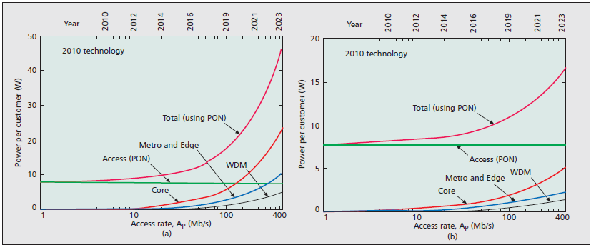
Fig. 2: Power consumption of Internet Infrastructure

dominate power consumption at high access rates. Fig 2a assumes 2010 technology. Considering constant improvements in energy efficiency fig 2b shows the power trends assum- ing a 10% annual improvement in energy efficiency of the metro/edge and core network equipment.
Fig 2 shows that the metro/edge network as well as the optical communications systems that connect between the core equip- ment does not dominate power consumption. The metro/edge equipment does not have to deal with the volume of traffic that occurs in the core. The WDM optical communications systems that connect the routers are relatively energy efficient in that they can transport substantial capacity at low power.

Access Networks and Content Dissemination Networks

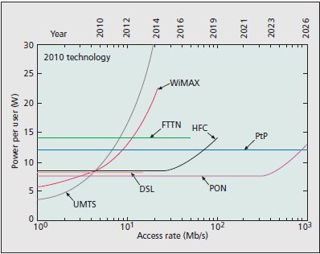
Fig. 3: .Power consumption per user for several access network technologies for a range of access rates

Fig 3 shows that wireless networks such as WiMAX and third-generation (3G)/UMTS consume significantly more power per user than fiber-based access for all but the lowest of access rates. High-speed wireless access is becoming in- creasingly popular because it provides mobility and ease of access to the Internet. However, unless the energy efficiency of wireless access is improved, its growing popularity may
be unsustainable. Fig 3 also shows that fiber-based access networks are the most energy-efficient technologies when high data rates are required.

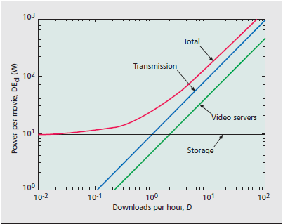
Fig. 4: Power consumption per Download for a standard definition
2 hours video that has 20 copies replicated in data centres

A content distribution network can be connected via the Internet or a private network. From Fig. 4, we see that the power consumed by storage of the content is constant and independent of the number of downloads per hour. The power consumed by the servers that respond to customer requests for content and extract the content from the disks, and the power required to transport the content from the data center to the customer depend on the number of requests for the content. This means the energy per download is being dominated by the storage (disk) power when there are only a few downloads per hour. If the content is popular, resulting in many downloads per hour, the energy per download is dominated by servers and the transport network because the storage power is shared amongst many customer requests.

From Fig 2, Fig 3 and Fig 4, it is clear that the three main areas requiring attention in the context of overall power con- sumption are access networks, content distribution networks

A GREENER APPROACH TOWARDS ENERGY EFFICIENT NETWORKING 3

and core network routers. Hence, we direct our efforts in de- veloping strategies for these ’hot spots’ of energy consumption.

3 ENERGY EFFICIENT CONTENT DISSEMINATION
The vast majority of Internet usage consists of content being disseminated from a source to a number of users. Growing demands for content distribution has led content service providers to invest in large data centres. Due to the sheer size, these consume significant energy: estimated to be 100 billion kWh costing $7.4 billion per year .
Along with the expansion of data centres, backbone network providers have been increasing network capacity to meet the ever increasing demands, by deploying a large number of high-speed routers and fiber transmission systems. However, the energy efficiency of current networking devices is reported to be very poor, and their power consumption does not significantly vary according to utilization.
Noting that routers are far more energy efficient than servers and access devices, a radical solution is to introduce content routers into the network as proposed in content-centric networking.

3.1 Towards Content Centric Networking
Content servers (in data centres or in users premises) are an order of magnitude less energy efficient than networking de- vices such as core/edge routers and optical multiplexers. This observation indicates that today’s host-to-host based content distribution is inherently less energy efficient and brings home to us the value of exploiting the capability of energy effi- cient networking devices using a radically different approach, namely content-centric/oriented networking where queries and data are routed based on content name, which can be either opaque or structured (as in URL). In recent years, a number of different approaches have been proposed in the research community such as TRIAD, Data-Oriented Network Architec- ture (DONA), and Content Centric Networking (CCN). Among these proposals,we focus on CCN because it provides an ideal platform for network-wide content caching[2].
CCN uses user-friendly hierarchical names like URLs. As in Bit Torrent-like file swarming, the original content is divided into multiple chunks. In CCN, the content publisher signs each chunk along with its name to guarantee secure linkage between the name and the content chunk; intermediate routers can validate an incoming chunk using this per-chunk signature. A content publisher announces content availability via Bor- der Gateway Protocol (BGP) prefix announcement. The basic operation of a CCN router is very similar to an IP router. An interest (or request) packet arrives on an interface, and then a longest-match lookup is done on its name to make a forwarding decision. Since CCN routers support caching within the network, any intermediate CCN routers on paths that have the requested chunk can answer the request. The request chunk is then delivered by following a reverse path created while forwarding the interest packet.This is illustrated in Fig 5.

3.2 Energy Efficiency Evaluation
Energy efficiency of the different content distribution strategies can be evaluated using certain set of traceroute data. The benefit of CCN under incremental deployment scenarios is

Fig. 5: Illustration of content caching in CCN
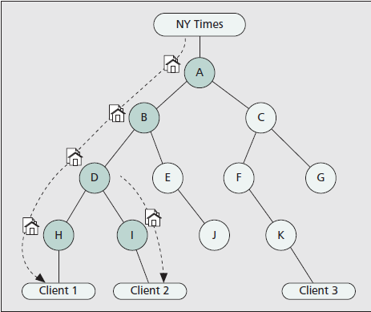

evaluated by varying the fraction of CCN-enabled routers from
20% to 100%. The total energy consumption for downloading
1 Gb of video content (125 Mbytes) is measured.

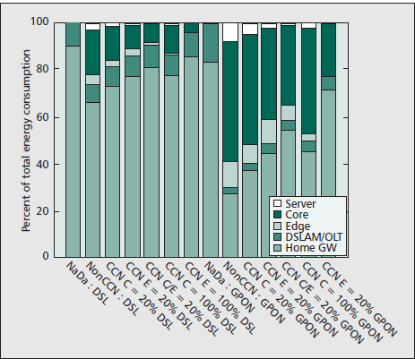
Fig. 6: Energy Consumption Breakdown

Fig 6 is plot of the percentage of total energy consumption of various components in the content delivery chain: server, core/edge router, DSLAM/OLT, and home gateway. It shows that home gateways contribute to a large fraction of the total energy consumption, and this fraction grows as the number of CCN routers increases. The overall trend is quite persistent in both DSL and GPON. As the fraction of CCN-enabled routers increases, the server cost decreases, because requests can be served in the intermediate routers. In the CCN scenario with
100% deployment in the edge, edge routers can fully serve the content; thus, there is no server cost in the energy consumption breakdown. In the CCN scenario with 100% deployment in the core, however, core routers may not fully serve the content, since requests could bypass core routers.The energy efficiency comparison via trace-based simulations shows that content- centric networking can substantially improve the energy ef- ficiency of content dissemination.

4 TOWARDS GREEN COPPER BROADBAND ACCESS
NETWORKS
DSL access multiplexers (DSLAMs) are used to terminate two- thirds of the 466 million BB(Broadband) users in 2009. The

A GREENER APPROACH TOWARDS ENERGY EFFICIENT NETWORKING 4

number of BB users is expected to exceed 800 million by 2013. Despite heavy investments in wireless and fiber-based tech- nology, still over 60% of users will be connected using copper twisted pair technology. Hence, energy savings for DSLAMs are still relevant to reduce the total energy consumption and associated C O2 emissions of BB access networks. Since WMI’s considered in a later section, we focus here on DSL based access networks.

4.1 Some Energy saving techniques
Following are some of the energy saving techniques for broad- band access networks:
• Improving the efficiency of analog technology : Current implementations for both ADSL2(plus) and VDSL2 rely on class AB operational amplifiers, which have just 24% efficiency for xDSL applications. We can uses Class G and H amplifiers which can ideally improve the efficiency up to 51% (Class G) or 58% (Class H).
• Spectral Management : The strategies in spectral opti- mization rely on the fact that the line driver power usage is closely related to the aggregate transmit power (ATP). Experiments have shown that, reducing the ATP with 6dB can reduce the power usage of the line driver by 40%. This will result in an overall reduction of the DSLAM energy consumption of 10% to 30% based on the fact that in the DSLAM, the line driver is responsible for close to half of the total energy consumption.
• Enabling stable low power mode : The ADSL2/ADSL2plus standard has a number of line states defined which can be used to reduce the energy consumption of the access line. The L0 state is the default state when the line is fully functional. The L2 state is a low power state in which the line is still active albeit with reduced transmit power in the downstream direction. Using the Artificial Noise Technique for ADSL2/ADSL2plus, we can achieve an energy efficiency of about 50% resulting from minimum required bit rate and other factors.
• Deployment Practises in Access Networks: It is seen that the energy consumption of equipments such as the DSLAM is almost the same as the energy consumption of the supporting functions for the same equipment, the largest contributor being active cooling. Hence explor- ing access node architectures that avoid active cooling, is worthwhile. In a typical central office environment multiple equipments are placed requiring needing active cooling subsystems. However, this concentration of energy consumption can be avoided by moving to a distributed architecture, where the line termination boards are dis- tributed closer to the user into remote cabinets (e.g. FTTn). The architecture proposed here is to keep some of the functionality in the central office and move the LT(Line Terminal) closer to the user by placing them into remote cabinets, duplicating certain functionality and introduc- ing some new ones. Using earlier mentioned technique of spectral management, and non-requirement of cooling leads to considerable saving of energy.A more detailed explanation is provided in [3].

4.2 Comparison
Applying the optimization techniques described above, we can compare the energy consumption of copper based access
networks with fiber based access networks. A number of architectures such as ADSL2+ deployed from the CO, VDSL2 deployed from the CO, VDSL2 deployed from the OSP and GPON FTTH.
From Fig 7, fiber to the user is the most energy efficient
while distributed DSLAM approach is second, showing a more energy efficient architecture than the CO based DSL solutions. This comparison shows that the distributed architecture for VDSL2 can be an alternative for GPON from an energy consumption point of view.

5 ENABLING BACKBONE ROUTERS TO SLEEP
Advanced features for power management such as entering standby modes, or scaling its working speed are already avail- able network devices. However, their activation is generally hindered by network protocols since they are specifically de- signed to be always available. Emerging research aim at dy- namically turning network portions off during light utilization periods, while meeting the operational constraints and current switching workloads. For instance, elements in standby (e.g., links or nodes) do literally ”fall off” the network, i.e., their presence is not felt. In core network scenarios, the falling off of any element generally triggers all network nodes to exchange signalling traffic, and to re-converge toward new network logical topologies and/or configurations, causing transitory network instabilities and signalling traffic storms.
To guard against these situations, we exploit two features largely present in today’s networks and devices: network resource virtualization and the modular architecture of nodes.

5.1 Introducing Smart Support for Standby Primitives
The features of network resource virtualization and the mod- ular architecture of network nodes are mainly based on the exploitation of today’s L2 protocols for backbone networks. In order to avoid unwanted drawbacks, the solution is completely transparent to L3: IP routing protocols are unaware of network change, so control message exchange and L3 reconfiguration are avoided.
The idea consists of making line cards left active ”cover” sleeping parts, without the device losing any networking re- source/functionality. So before a line card enters standby sta- tus, it has to transfer its resources and activated functionalities to other cards that will remain active. This obviously requires a new L2VL(L2 Virtual Links) remapping on the physical network topology, since each L2VL has to enter the device from the PHYs of other line-cards. The step beyond this and the most innovative part of the approach consists of making the L2 remapping, and then also standby hardware transitions, totally transparent to the IP layer.
If each L2VL of the sleeping line card is remapped on another active line card, the network node sees the same number of L3 interfaces (i.e., the L2 Terminations), which connect the local router to the same set of IP nodes as before the L2VL migration. In other words, the full remapping at L2 results in an L3 overlay topology substantially identical to the starting one.
Standby state of line cards cannot be locally managed by
routers, since it requires the reallocation of a number L2VLs across the network. For this reason, a network control unit (NCU) is used, a network node devoted to collecting traffic load information from the routers, and to consequently apply

A GREENER APPROACH TOWARDS ENERGY EFFICIENT NETWORKING 5

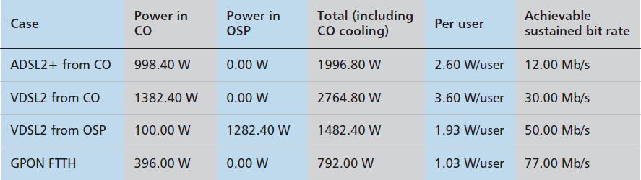
Fig. 7: Comparison of DSL and GPON.

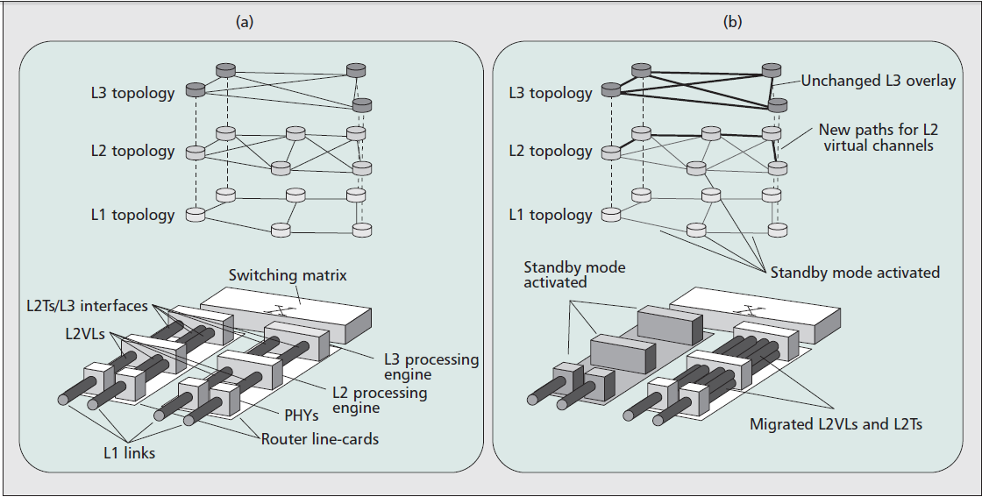
Fig. 8: State-of-the-art backbone network and device scenario in sub figure a), and, in sub figure b), the proposed approach to enable network devices to selectively sleep their components

a traffic engineering criterion to perform the L2VLs reconfigu- ration, and to meet the QoS constraints. The NCU continuously monitors if incoming traffic volumes exceed fixed thresholds. When traffic volumes exceed such thresholds, the NCU exe- cutes the TE(Traffic Engineering) algorithm and detects which line-cards of routers have to sleep or to wakeup. More details are given in [4].
The TE algorithm is devoted to finding the optimal network configuration that can be achieved by remapping L2VLs on the physical topology. The optimal configuration is the one that maintains the QoS constraints in terms of maximum link utilization and backup availability, and allows the largest number of line cards to sleep. The TE algorithm is based on the link traffic load, and can be summarized as follows:
• The set of all router line cards LCij (where i and j represent the identifiers of the router and line card, respectively) is ranked in increasing order of traffic load.
• The minimum load line card is selected, LCmin , and removed from LCij .
• LCmin ”standby” is evaluated: all the L2VLs using the PHY interfaces of LCmin are remapped: new path not using LCmin is searched. If a new path for all the involved L2VLs is found, LCmin can enter standby and LCij is updated; otherwise, it has to remain active.
• If all the network line cards are not tested, return to step
2.

5.2 Performance Evaluation
To evaluate the performance, the two different topologies composed of 159 nodes and 614 links, and 244 nodes and 1080
links, and, three traffic levels η, where η = 75%, 50%, and 25% of the maximum load traffic matrix, respectively are taken into consideration.
The results are reported in fig 9, and are expressed as the percentage of physical line cards that can be put to sleep. Even in the presence of high traffic volumes (η = 75%), the results demonstrate that, more than 40% of line cards can enter standby modes. When traffic levels decrease, standby primitives can be enabled on more than 50% of line cards. Each line card consumes 70 W when active and 10 W in standby mode. Fig 7 shows that network energy absorption can be reduced by a more than 40%.

6 ENERGY EFFICIENT WIRELESS MESH INFRASTRUC-
TURES
Recent developments in wireless technologies have made them attractive as part of the access segment of the Internet. Their flexibility, permitting in most cases terminal mobility and saving on infrastructure for the operator make them highly favourable. On one hand, cellular systems have evolved to- wards more efficient data transmission, and today can be useful for some data services. On the other hand, IEEE 802.11 (WiFi) technology has become widespread, and its maximum link capacity matches that of some wired technologies. Ad- ditionally, new technologies have become available, such as IEEE 802.16 (WiMAX), with base station (BS) capacities close to those of ONUs. Wired and wireless technologies in the access segment can be combined in order to increase resource utilization efficiency while satisfying the users demands. We can expect future access networks where ONUs are integrated

A GREENER APPROACH TOWARDS ENERGY EFFICIENT NETWORKING 6

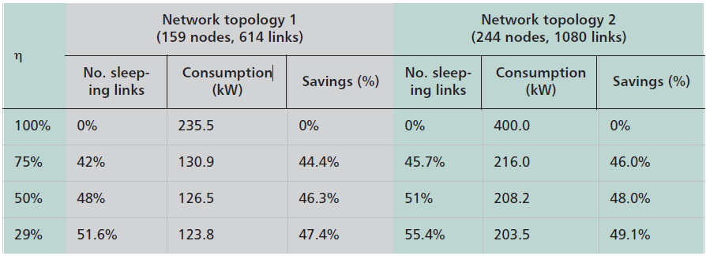
Fig. 9: Maximum number of line cards that can be put to sleep , energy consumption, and savings according to different traffic volumes in two physical topologies

with WiMAX BSs, WiFi access points (APs), or new-generation cellular BSs. These wireless nodes could be connected to form a wireless Mesh Infrastructure (WMI). The WMI is formed by a set of static, wireless devices, which we call wireless mesh nodes (WMNs). User terminals, which can be static, nomadic, or mobile, connect to a WMN via one wireless hop, thereby alleviating the complexity of multi hop wireless routes involving several mobile devices and relieving the user terminals of forwarding third-party packets.
Despite the above mentioned advantages of WMIs, the energy efficiency of wireless transmission is relatively low. Com- parative energy consumption data of WiMAX and several wire/optical-based access technologies in Fig 3 shows that WiMAX has the highest energy consumption per data unit. The difference is especially visible for high data rates where the energy consumption per data unit with WiMAX decreases very slowly, where as the other technologies are significantly more efficient. There is a serious need to improve its energy efficiency because wireless is the future of access networks.

6.1 Reducing Energy Consumption and Increasing Energy
Efficiency in WMI’s
Methods for reducing energy consumption in WMIs can be distinguished between local and distributed methods. Local methods consider only a few parameters and are dedicated to single devices, while distributed methods consider solutions involving several nodes, coordination among those nodes, and feedback loops.
The main local energy reduction concepts are:
• switching network interfaces on/off
• Adapting transmission ranges, modulation formats, and coding schemes
• select wireless consuming less energy
• relaying messages by ad hoc network to increase coverage
• Decreasing the number of active users by increasing the transmission power, introducing compensation methods for service degradation(using FEC).
• Including Delay/Disruption Tolerant Networking (DTN) A detailed discussion about these techniques is discussed in [5].
The choice of the energy efficiency method is based on the
constraints for the service provisioning combined with the traf- fic pattern. Given these categories, there are different ways of implementing the methods based on how decisions are made, in either a reactive manner, based on traffic measurement and
detection, or a proactive manner, based on the presence of mobile devices and load prediction. Reactive implementations adapt to currently observed situations, which means they are always ”one step behind”. Proactive implementations involve the invocation of mechanisms fitting a situation before the situation occurs. This implies that it is feasible to invoke the mechanism in advance. The main advantage of proactive implementations is the reduction of delay, but the prime dis- advantage is the possible wrong invocation of mechanisms.In future heterogeneous networks, nodes are expected to be dy- namic in terms of mobility and load generation. To react to these dynamics in time, mobility prediction and load prediction are used.
Some possible scenarios are considered in [5] in which the solutions for energy efficiency, that are described above, are applied. It also shows a comparison of the possible energy savings obtained.

7 RETHINKING ENERGY EFFICIENCY MODELS OF CEL-
LULAR NETWORKS WITH EMBODIED ENERGY
Approximately 3% or 600 TWh (Terawatt-hour) of the total worldwide electrical energy is consumed by information and communication technology (ICT), in which the total electric energy consumed by telecommunications equipment is esti- mated at one third of that. Representing the strongest branch of the telecommunication sector, mobile telephony is responsible for half of its consumption. Detailed insight reveals that 10% of the entire consumption is associated with the end-user equipment, while the remaining 90% is taken up by network components, of which around 2/3 is used by the base stations (BSs). The quick depleting fossil fuels with increasing C O2 emissions coupled with hefty Operational Expenses (OPEX) are two major driving forces for further research and development in this field.
Past research has dealt with - powering down underutilized BS while active BSs power has to be increased, cell size optimiza- tion, shutting down cell with no active users, improving the operating energy consumption ratio and employing two tier cellular access networks. There are two notable drawbacks to the above suggestions that require attention. Even if we disre- gard the problem of most today’s widely employed BSs not yet supporting a sudden total power-down strategy, there is still the issue of embodied energy consumed by manufacturers to produce high-tech equipment such as BSs. This new model considering embodied energy is not limited to just cellular

A GREENER APPROACH TOWARDS ENERGY EFFICIENT NETWORKING 7

networks, but to other telecommunications, such as wireless local area networks and wired networks.

7.1 Embodied Energy and Energy Assessment of a BS

Embodied energy, EEM , is the energy consumed by all pro- cesses associated with the production of a device. Experimental studies indicate that embodied energy represents a relatively small part of the total energy in the case of houses (7% to 10%) or cars (10% to 15%) compared to electronic devices such as BSs (30% to 40%) [6].
The approach to evaluate the energy assessment of a BS uses a methodology similar to that of a recently published work [14]: disassembling of a BS and building the life-cycle inventory for the most notable components, materials, and processes for a general BS. The total initial embodied energy of the general BS has been assessed by summing the results provided in [6].

7.2 Cell number / Coverage area Trade-off

The energy consumption model is now applied to two sce- narios, one including the power-down strategy and the other excluding it. Energy consumption optimizations are done with respect to the number of cells and their coverage, considering the trade-off between operating and embodied energy using simulations.

7.3 Without Power Down Strategy

The transmission power of BS antennas is dissipated into the air, and the transmitted signal is deteriorated by path loss, shadowing, and multipath fading effects in wireless propa- gation channels. The average receiving power decreases with distance d between the receiver and transmitter approximately
1/(d)γ , mainly accounting for the path losses, where γ is the
path loss exponent that typically ranges from 2 to 5, depending on the propagation environment. The energy model for the whole system consumption, Esystem , for the scenario without power down strategy of a certain area covered by n BSs can be expressed as

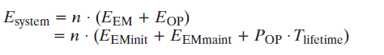

where the operating power POP is a function of cell radius, EEM = Embodied energy, EEM init = Initial embodied energy, EEM maint = Maintenance embodied energy, EOP = Operating energy and Tlif etime = (Commercial) lifetime of base station.

The Number/Coverage Trade-Off

The deployment of a larger number of BSs with smaller size (cell radius) will enable the reduction of transmit power of BSs as well as operating power and electromagnetic radiation. However, the total energy consumption of the system is the multiplication of the number of BSs and a single BS energy consumption. As the number of BSs becomes large, the system consumption rises, since the embodied energy of a newly deployed BS adds to the total energy. The trade-off between the number and coverage of a single BS translates into a trade-off between the embodied energy and operating energy.
7.4 With Power Down Strategy
The power-down strategy is an important energy saving tech- nique adapting BS activities to traffic dynamics. When the traffic of a certain cell remains at a low level, the BS can be shut down for operating energy savings purposes. The other active BSs should increase their transmission ranges by increasing the transmission power to cover the entire area. When the traffic in a cell increases, the shut-down BS will be activated. Thus, when the power-down strategy is applied, the operating power of the system varies with the number of active BSs.
The entire system consumption Esystem for the scenario with power-down strategy is expressed as follows:

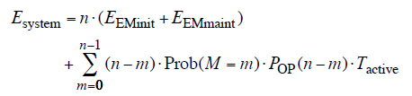

With probability ’p’ of shut down, ’n’ number of BSs and
’M’ is a random variable (M=m).

7.5 Simulation results
Fig 10 shows the simulation results of energy consumptions with different number of BSs or cell sizes, including and excluding the power-down strategy,to find the optimal number of BSs or cell size. When only a small number of BSs with large cell sizes are deployed, the energy consumption is high; this is due to the increased operating energy with cell size. However, when a large number of BSs with small cell sizes are deployed, the embodied energy consumption dominates and leads to an increase in total energy consumption. The optimum is achieved with the trade-off between operating energy and embodied energy.
These results indicate that further solutions of energy efficiency optimization should consider a trade-off between the embod- ied and operating energies in cellular networks.

8 GREEN WIRELESS COMMUNICATIONS VIA COGNI-
TIVE DIMENSION
Telecommunications data volume increases approximately by an order of 10 every 5 years, which results in an increase of the associated energy consumption by approximately 16% to 20% per annum. A major portion of this expanding traffic has been migrating to mobile networks and systems. With the expanding domination of multimedia services/traffic in wire- less networks, the spectrum requirements and computational burden on these mobile devices are also toughening in contrast to the perpetual trend of equipment miniaturization. Cognitive radio (CR) is a promising paradigm proposed to cope with the spectrum scarcity problem that has emerged as a result of increased need for any time anywhere connectivity [12]. Briefly, CR (also called smart radio) is defined as a wireless radio device that can adapt to its operating environment via sensing in order to facilitate efficient communications [13].Cog- nitive abilities that refer to a wide range of properties, from spectrum sensing to learning-empowered adaptive transmis- sion in wireless network nodes, are beneficial for leveraging intricate trade-offs between energy efficiency, performance, and practicality. Nodes coupled with these cognitive functionalities, known as cognitive nodes, can improve network performance by environment-aware and self-aware operation capabilities.

A GREENER APPROACH TOWARDS ENERGY EFFICIENT NETWORKING 8

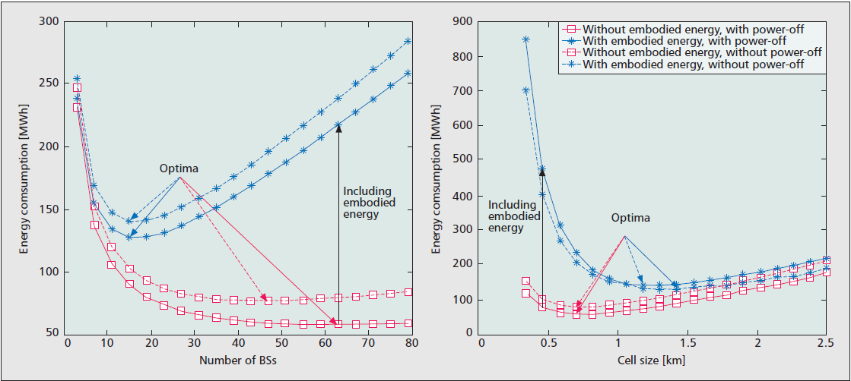
Fig. 10: The optimal energy consumption of a cellular network with respect to the number of BSs or cell sizes.

8.1 Benefits of Cognitive Radios for Green Wireless Com- munications
A CR is supposed to perform an envisaged cognitive operational cycle shown in Fig. 11. CR senses its electromagnetic operational environment by its sensors. After processing these sensory readings that represent the state of the environment, CR plans and decides on its actions considering its goals, priorities and constraints. With these self awareness and environment-awareness capabilities, a CR can select the best strategy meeting its goals. Upon deciding on the most appropriate strategy, CR acts accordingly. All steps interact with the embedded learning module. In other words, a CR learns from its experiences which also makes it smart. The energy efficiency related functionalities should be embedded in these flows, and also these processes themselves should be made energy-efficient.

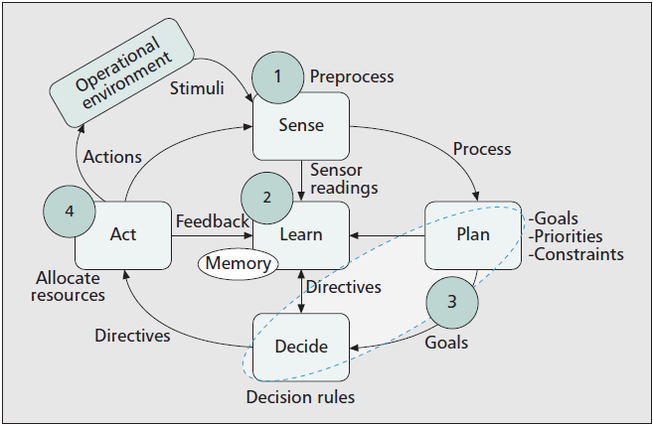
Fig. 11: Cognition Cycle

CR has been proposed as a general approach for higher efficiency in wireless communication systems. Moreover, from
the green perspective, spectrum is a natural resource which should be shared instead of being wasted. CRs enable this paradigm with smart operation and agile spectrum access. But they also have to be optimized on the way to green communications.To this end, the capabilities of CRs enable a diverse set of energy efficiency optimizations in different communication settings:

• Intelligent support for energy efficient functionalities - Power supply and energy efficiency awareness is possible with CRs since the CR knows the source of its power supply, the remaining battery life, and the energy effi- ciency of alternative adaptation schemes. CRs encompass the sensor and computational infrastructure for enabling these capacities.
• Duty cycle optimization and robustness in ad hoc set- tings can save energy - Dynamic spectrum access in CR can alleviate the problem of ad-hoc nodes via switching to backup channels, estimation of further link qualities.
• Network layer capabilities - Selection appropriate based on physical layer condition, available bandwidth and also energy cost in layers.
• Cross layer optimization - Measuring performance re- quires taking into account the characteristics of the proto- col stack, whereas optimizing energy expenditure relies on the detailed knowledge of the low-level radio hardware. The applications in cognitive networks will be able to interact with the radio for more flexible and adaptive operation. This enables context aware operation in the lower layers under application-driven smart schemes. On the infrastructure side, network nodes with cognitive capa- bilities may optimize their energy efficiency using different control dimensions.
• Enabler for ubiquitous efficiency optimization
• Physical layer capabilities - Signal in multi-carrier trans- mission schemes such as OFDM. CR sensors provide data support for power-efficient PAPR reduction techniques. Furthermore, cognitive mobile devices will have the in-

A GREENER APPROACH TOWARDS ENERGY EFFICIENT NETWORKING 9

telligence to select the most energy-efficient PHY profiles based on the present channel state via learning and esti- mation.
• Bandwidth Energy trade-off - May prefer bandwidth expansion to minimize power consumption in valid op- erational opportunities without sacrificing throughput.
• Simpler and more efficient evolution paths - The soft- ware defined nature of CR allows the modification of energy saving schemes in operation. Enables more au- tonomous operation and self configuration for network nodes.
• Smaller impact on human health - Avoiding EM pollution via the proper use and sharing of spectrum resources for protecting human health.

9 CONCLUSION
As these articles show, addressing energy efficiency in net- works requires addressing all layers of the network stack, considering both technologies and network management. Ap- proaches should be based on how energy is actually used in networks.As the world becomes more energy constrained, humankind will need to develop and refine strategies for improving the energy efficiency of the Internet. A ”common rule of thumb” is the ”80/20 rule,” which states that 20% of causes produce 80% of effects. In this report, the strategies to address this 20% have been identified. To fully estimate and improve the energy efficiency of networks, researchers, manufacturers, operators, and regulatory authorities should work together to establish a framework of energy efficiency covering all communication stages, which include the concept definition, life cycle assessments, standards regulation, expense estimation, and so on. If this is done, a greener network would indeed emerge, in the next round of the networking revolution.

REFERENCES

[1] Power Consumption and Energy Efficiency in the Internet Kerry Hin- ton, Jayant Baliga, Michael Feng, Robert Ayre, and Rodney S. Tucker, University of Melbourne
[2] Energy-Efficient Content Dissemination Uichin Lee, KAIST KSE, Ivica
Rimac, Daniel Kilper, and Volker Hilt, Alcatel-Lucent Bell Labs
[3] Green Copper Broadband Access Networks Koen Hooghe and Mamoun
Guenach, Alcatel-Lucent Bell Labs
[4] Backbone Networks to Sleep Raffaele Bolla, University of Genoa, Roberto Bruschi, National Inter-University Consortium for Telecommunications (CNIT) Antonio Cianfrani, and Marco Listanti, University of Rome Sapienza
[5] Energy-Efficient Wireless Mesh Infrastructures Yahya Al-Hazmi and Hermann de Meer, University of Passau Karin Anna Hummel and Harald Meyer, University of Vienna Michela Meo, Politecnico di Torino David Remondo, UPC Barcelona Tech
[6] Rethinking Energy Efficiency Models of Cellular Networks with Em- bodied Energy Iztok Humar, Huazhong University of Science and Technology and University of Ljubljana Xiaohu Ge and Lin Xiang, Huazhong University of Science and Technology Minho Jo, Ko- rea University Min Chen, Seoul National University Jing Zhang, Huazhong University of Science and Technology
[7] Green Wireless Communications via Cognitive Dimension: An Overview
Grkan Gr and Fatih Alagz, Bogazici University
[8] J. Baliga et al., Energy Consumption in Optical IP Networks J. Light- wave Tech., vol. 27, no. 13, 2009, pp. 2391403.
[9] J. Baliga et al., Power Consumption in Access Networks OFC 2008, paper OThT6, 2008.
[10] J. Baliga et al., Architectures for Energy-Efficient IPTV Networks
OFC/NFOEC 2009, paper OThQ5, 2009.
[11] J. Baliga et al., Carbon Footprint of the Internet Telecommun. J.
Australia, vol. 59, no. 1, 2009, pp. 05.105.14.
[12] J. Mitola, Cognitive Radio Architecture Evolution: Annals of Telecom- munications, Annals of Telecommun., vol. 64, no. 7, 2009, pp. 41941
[13] S. Haykin, Cognitive Radio: Brain-Empowered Wireless Communica- tions, IEEE JSAC, vol. 23, no. 2, Feb. 2005, pp. 20120
[14] P. Mahadevan, A. Shah, and C. Bash, Reducing Life cycle Energy Use of Network Switches Proc. IEEE Intl. Symp. Sustainable Systems and Tech., Arlington, VA, May 2010.

